[Enw’r Practis Meddyg Teulu]
[Llinell Cyfeiriad Cyntaf]
[Ail Linell Cyfeiriad]
[Tref/Dinas]
[Cod post]
[Rhif Cyswllt]
[Dyddiad]

Annwyl [Enw]

Mae'n bryd cael eich brechiad rhag y feirws syncytiol anadlol (RSV).

Bydd eich apwyntiad ar:

_________________________________ am: ______________________am/pm

Lleoliad:__________________________________________________________

Os nad yw'r apwyntiad hwn yn gyfleus, gallwch: [dileer a chwblhau gyda'r manylion.
- ffonio ni ar (XXXX);
- gysylltu â ni drwy ein gwefan yn (XXXX); neu
- e-bostio ni yn (XXXX).]

Mae RSV yn achos cyffredin heintiau yn y pibellau anadlu, megis y trwyn, y gwddf, y llwybrau anadlu neu'r ysgyfaint.

I’r rhan fwyaf o bobl, mae feirws syncytiol anadlol (RSV) yn achosi salwch ysgafn, fel peswch neu annwyd. Fodd bynnag, mae pobl hŷn mewn perygl o gael salwch difrifol, yn enwedig os oes ganddynt gyflyrau iechyd, megis clefyd y galon neu'r ysgyfaint neu system imiwnedd wan. Weithiau, bydd angen i bobl sy’n mynd yn sâl oherwydd haint RSV fynd i’r ysbyty.

Mae’r brechlyn RSV yn cael ei gynnig fel un dos i bobl 75 i 79 oed (neu’r rhai sydd wedi troi’n 80 oed yn ddiweddar). Mae cael eich brechiad RSV yn un o'r ffyrdd gorau o helpu i ddiogelu eich hun rhag salwch difrifol.

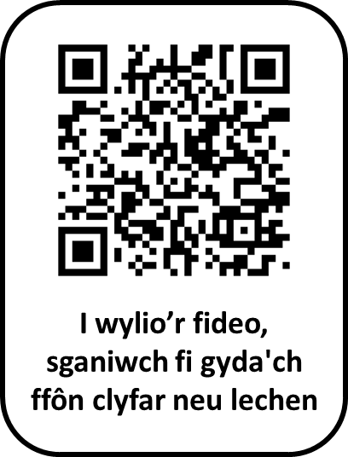
I gael rhagor o wybodaeth am y brechlyn RSV, gallwch wneud y canlynol:
- mynd i wefan Iechyd Cyhoeddus Cymru yn
icc.gig.cymru/RSV-oedolion-hyn
- gwylio fideo byr gan Iechyd Cyhoeddus Cymru (trwy sganio'r cod QR); neu
- gysylltu â'ch practis meddyg teulu.

Yr eiddoch yn gywir

Dr [Enw] a phartneriaid
Practis Meddyg Teulu [Enw]

[Insert GP Surgery]
[First Address Line]
[Second Address Line]
[Town/City]
[Postcode]
[Contact Number]
[Date]

Dear [Name]

It is time to get your respiratory syncytial virus (RSV) vaccination.

Your appointment is on:

_________________________________ at: _______________________am/pm

Location:__________________________________________________________

If this appointment is not convenient, you can: [delete and complete with details.
- phone us on (XXXX);
- contact us through our website at (XXXX); or
- email us at (XXXX).]

RSV is a common cause of infections in the breathing passages, such as the nose, throat, airways or lungs.

For most people, RSV causes a mild illness, such as a cough or cold. However, older people are at risk of serious illness, especially if they have health conditions such as heart or lung disease or a weakened immune system. Sometimes, people who get ill from RSV infection need to go to hospital.

The RSV vaccine is offered as a single dose to people aged 75 to 79 (or those who have recently turned 80). Getting your RSV vaccination is one of the best ways to help protect yourself from severe illness.

For more information about the RSV vaccine, you can:
- visit the Public Health Wales website at
phw.nhs.wales/RSV-older-adults;
- watch a short video by Public Health Wales (by scanning the QR code); or
- contact the surgery.

Yours sincerely

Dr [Name] and partners
[Name] Surgery

